A Mobile Activism User’s Guide

By Jed Alpert
Founder, Mobile Commons
for Socialbrite.org
June 2009

Introduction

In this guide, we’ll introduce you to the world of mobile activism and show you how you can take your organization mobile.

Mobile is a complex ecosystem, and it includes:

- Telecom Carriers
  - All mobile traffic is routed through telecom providers like Verizon, T-Mobile, and AT&T.

- Handset Manufacturers
  - A wide variety of companies manufacture mobile devices, from Apple’s iPhone to boutique brands you haven’t heard of yet.

- The Internet
  - A small number of mobile phones (about 5%) have web capability - users can check email and surf the web, though the experience can be uneven at times.

- Application Providers
  - Mobile application providers allow you to create and manage your mobile programs, often from a web-based application.

We’ll mention a few pertinent facts about each of these areas, but we’ll focus mostly on application providers; good providers will serve as a one-stop shop, so you won’t have to deal with any complexity.

First, though, a short introduction to the various forms mobile programs can take….

Mobile Downloads

There’s a good deal of buzz surrounding mobile applications like ringtones and wallpapers. There are some drawbacks, however:
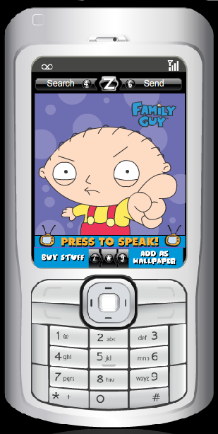
- They don’t work on every phone.
- Ringtones and wallpapers require users to download content.
- Depending on your programming, mobile applications can require heavy customization and lengthy development time.

SMS Messaging & Voice Applications

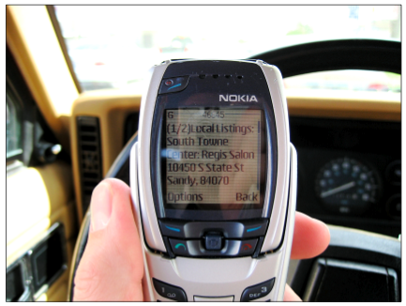
- Text messaging is becoming the most popular form of communication on Earth. Mobile subscribers send more than 1 billion SMS messages per day in the US alone.

Basics of SMS Messaging

Text messaging, or SMS (Short Message Service), is everywhere. In some parts of the world, text messaging is far more popular than traditional telephone calls. Here in the US, text messaging isn’t just for the young anymore; SMS is popular among nearly every demographic, and the average age of a texter is 30+.

And why not? After all, text messages are concise (up to 160 characters) and timely, and they can reach your supporters wherever they are. (95% of mobile subscribers have their handsets within arm’s reach 24/7.) Better yet, mobile is a non-SPAM, opt-in-only medium. And for that reason, text message open and response rates are higher than in any other medium. In other words, mobile is a great way to reach out and mobilize your supporters – anytime, anywhere.

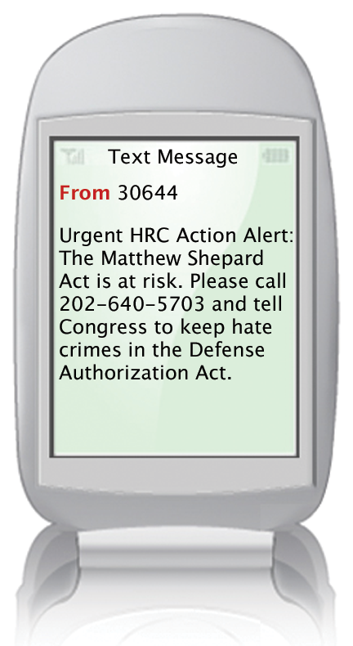

Getting Started

I’m interested in mobile; what’s my first step?

First, you’ll choose a mobile application provider – a software solution that will let you create and manage your mobile campaigns. Using that software, you’ll create a text messaging program and encourage your supporters to opt in by either

- texting a keyword to a short code, or
- filling out a webform on your webpage.

When a user does so, he will receive an automatic response message welcoming him to your campaign.

Short Codes

So what’s a short code? A short code is just a 5- or 6-digit number that’s used for opt-in text messaging programs. Mobile application providers will often provide you the use of a shared short code as part of their fee. This means that you’ll be able to create keywords on that short code and then encourage your users to opt into your program.

Your mobile application provider may have other clients using this short code as well – this is what’s called a “shared” short code. Don’t worry –
your data is secure, because your mobile programs are distinguished from other groups’ programs by your keywords.

Can I get my own short code?

If your organization wants its own short code for branding purposes or any other reason, you can lease one from the Common Short Code Administration. (Typically, your mobile application provider will do this for you.) There will be some extra costs involved – the carriers will need to review and approve your program, and you’ll have to pay to lease the code. (It costs $500/month to rent a randomly chosen short code, and $1000/month for a vanity short code.) It also takes 6-12 weeks to get a short code approved, aggregated, and provisioned across all of the carriers.

I’ve built a list of subscribers – now what?

Now you can do all kinds of things – mobile petitions, geo-targeted event notification, mobile town halls, rapid media response, text-to-call and text-to-screen campaigns, database-backed programs, or anything else you can think of. Just remember, text messages are most effective when you convey timely, urgent, and/or action-oriented information to your users.

A great example is GOTV; if your work involves turning people out to the polls, then you need to be using mobile. Recent studies by Princeton and the University of Michigan have shown that users who receive a text message reminder to vote on the day before an election are 4-5% more likely to do so.

CRM Integration

Depending on your mobile application provider, you can even integrate your mobile campaigns with your CRM data. Doing so allows you to target your messaging more precisely and conduct better data analysis on the back-end.

Text-to-Call Applications and User Experience

- When people opt in (or at any point thereafter), you can choose to send them a text-to-call message. This message will include a phone number; when the user connects to the number, they will hear a talking points audio message before being connected to the destination number you’ve specified.
- The user can connect by just pressing a button or texting back ‘call.’

Text-to-Call Applications: The Client Experience

- Clients can create text-to-call programs by deciding where they want to direct calls. They can upload an audio file or they can call in and record a message.

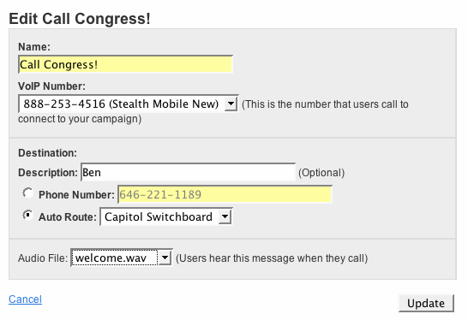

Text-to-Call: The Client Experience: Step 2

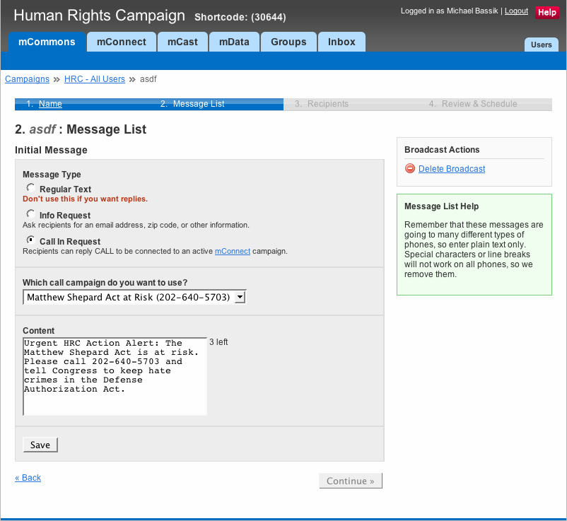

Text-to-Call: The Client Experience: Step 3

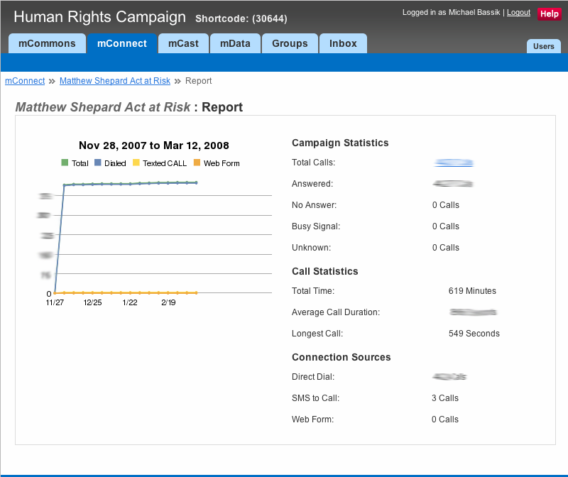

Text-to-Screen Applications

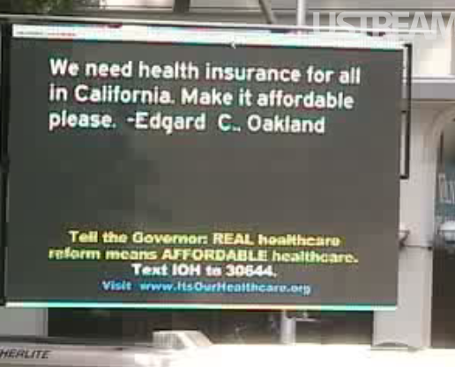



Text-to-Screen User Experience
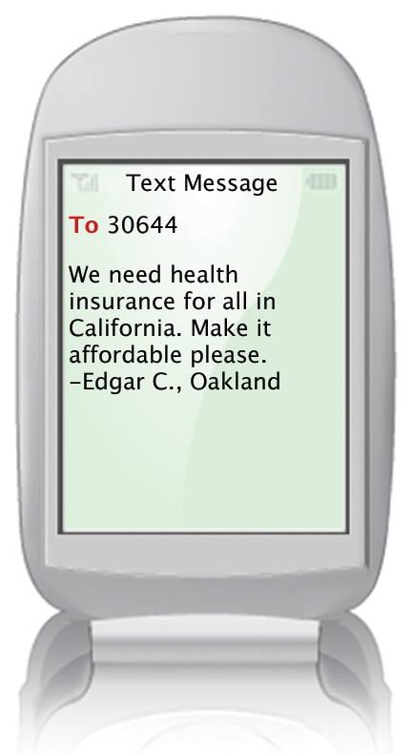

Messages can be pushed to Jumbotrons and screens, like this one in front of the California State House.

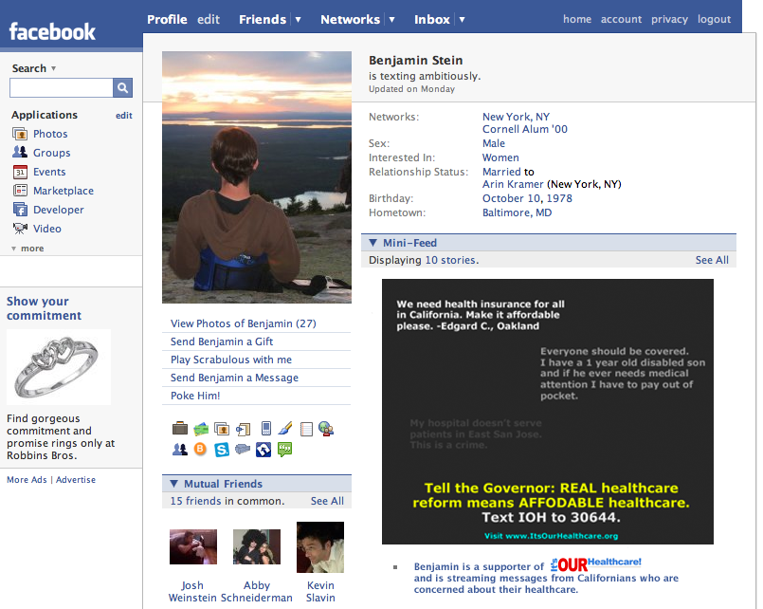

or

You can syndicate messages across the entire web with flash widgets or tools for developers.
How Easy is Setting Up a
Text-to-Screen Campaign?

Mobile clients push messages out by moderating incoming messages in a mobile vendor’s user interface. Simple.

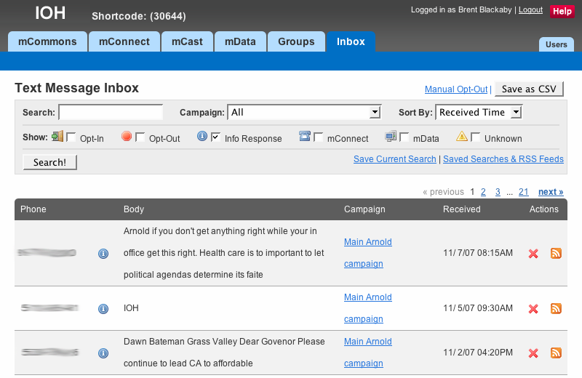

Data Applications

The Blue Ocean Institute gets thousands of queries from people at supermarkets, restaurants, and on the go.

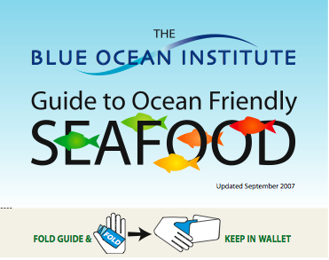
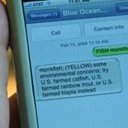

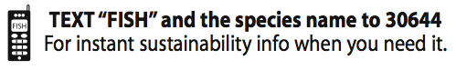

Data Application User Experience

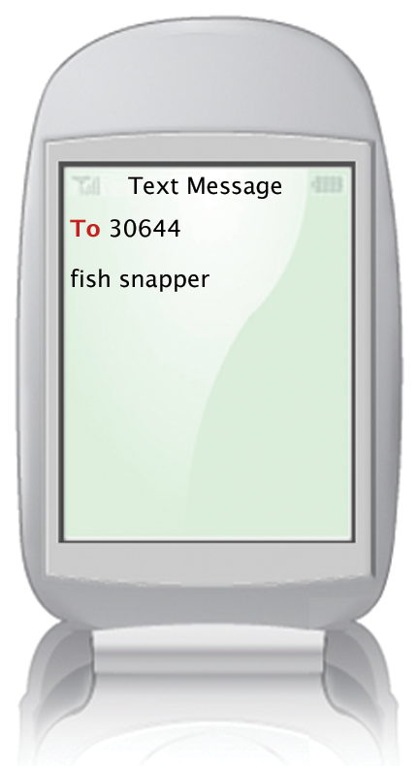
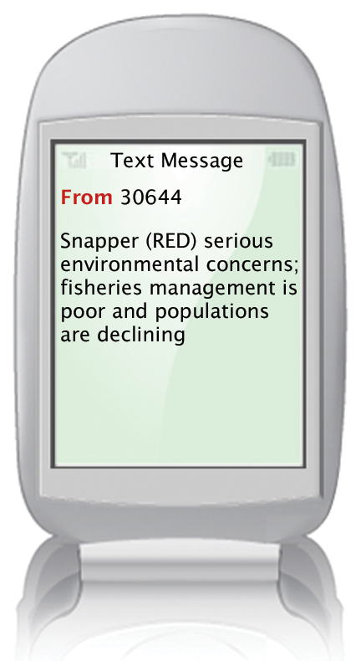



Data Applications: How Easy Are They? Step 1: Make a Spreadsheet

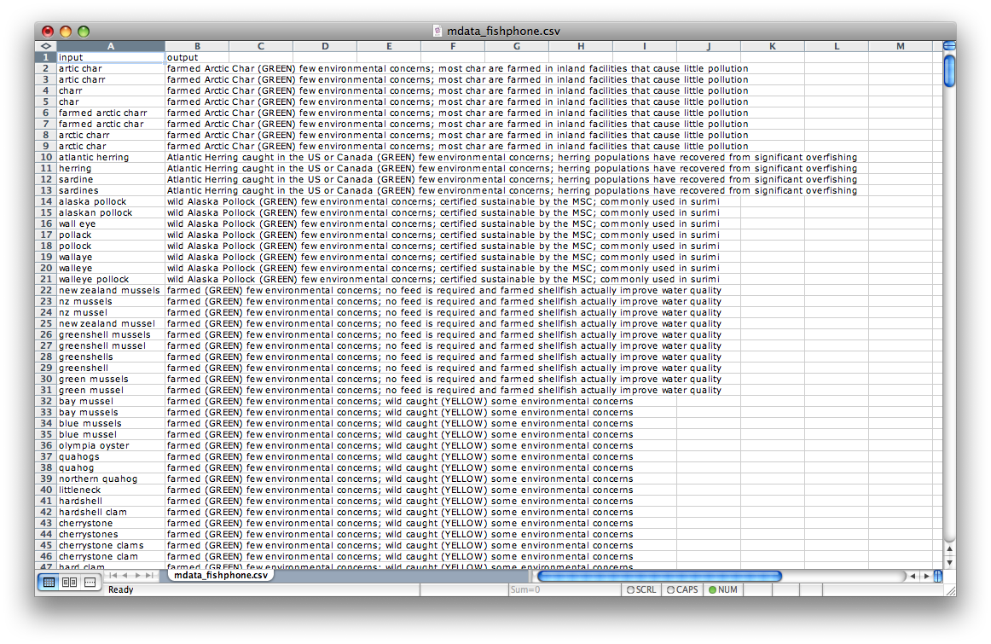

Step 2: Upload the Spreadsheet or use an API
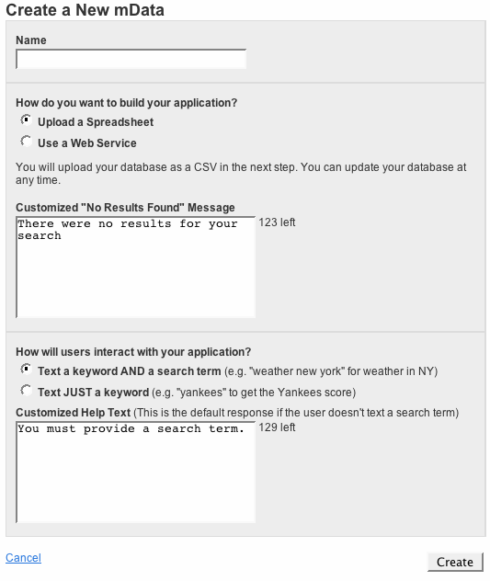
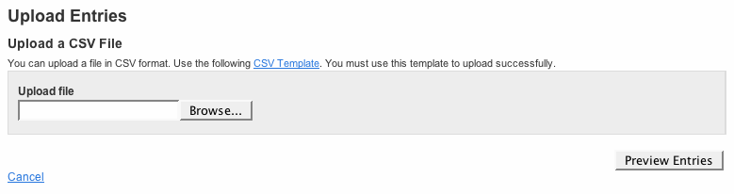

It takes less than 5 minutes!

You’re done!

People Interact Online and Offline



